# COVID PREDICTOR

COVID-19 has become a household buzz for past few months. Being asymptomatic, it could affect people in the worst way possible. The idea here is to assess a person’s risk based on his/her age, gender, lifestyle and underlying medical conditions. Analyzing data at such granular level would enable the assessment of risk an individual might face.

Idea:

With this project, we wanted to help people to make sense of the vast amount of information available and to make evidence-based decisions. We are trying to give individuals a rough estimate of their risk- or more precisely, the risk of people with similar characteristics as them of contracting COVID 19.

With the big data growth in healthcare, accurate analysis of such data could help in early disease detection and better patient care. We have built a machine learning model that could predict the risk of getting infected from COVID -19 for any person. Our approach takes into consideration Age, Gender, preexisting diseases, Foreign Travel as these are relevant features and are contributing to the spread of this disease. Our model would be beneficial to individuals and healthcare authorities by assisting them take appropriate action in case they are shown to be at high risk.

The Architecture:

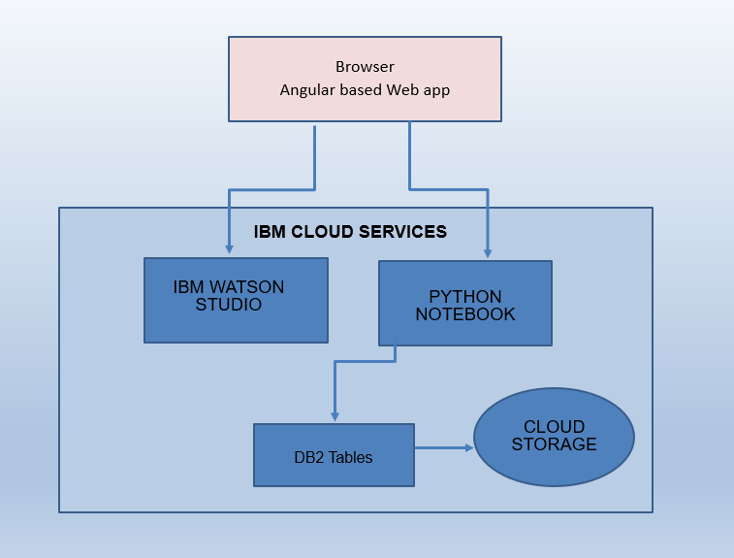

1. The user navigates to the site and enter his details.
2. Python code and AUTO AI in IBM Watson Studio reads the input and predict the risk.
3. The app stores the data within Object Storage.

Technology Used:

**FRONT END:**

The front-end is created in angular which consists of a form component that takes User details such as Name, Age, Gender, Location, Pre_Existing_Disease, Symptoms and Foreign_Travel.   
On click submit we are calling an API by passing the user details along with that API which triggers the backend code and gives the prediction response to the UI. The received response is shown to the user.

|  |
| --- |
|  |

**PREDICTION MODEL:**

Prediction Model is using AutoAI feature of Watson Studio which takes in training data set and provides best approach or pipeline. In our case it selected Random Forest Classifier.

Random forests or random decision forests are an ensemble learning method for classification , regression and other tasks that operate by constructing a multitude of decision trees at training time and outputting the class that is the mode of the classes (classification) or mean prediction (regression) of the individual trees. Random decision forests correct for decision trees' habit of overfitting to their training set.

This Classifier is modelled into notebook and deployed as a web service. Through that we could run the prediction model.

